What does Art and Design look like at our school?
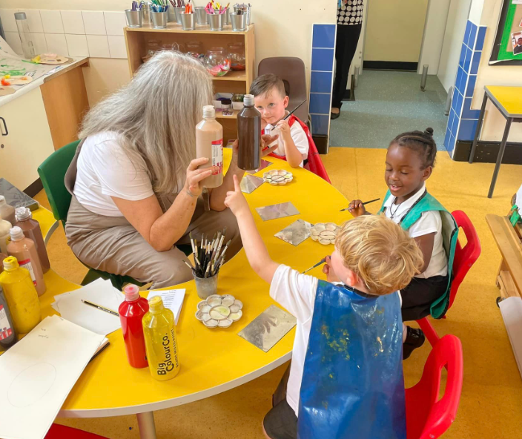
Our Art & Design curriculum has been designed to meet the statutory requirements of the National Curriculum; the programmes of study being the basis for learning and adapted to meet the needs of our pupils. We are always refining our curriculum in line with the latest guidance, subject research reports from Ofsted and current affairs.
We recognise the importance of Art and Design lessons and the impact they have on a child’s ability to interact with the world around them. Art encourages creativity and imaginative thinking and provides a new set of skills for self-expression and communication.
As part of our Art and Design curriculum, we teach children to discuss, analyse and take inspiration from different artists and their work, develop their own ideas and refine their techniques and skills. We endeavour to introduce children to pieces of art work from a diverse range of artists ensuring that all children feel represented and included. We then use this inspiration to stimulate our own ideas and create a piece of art work in response.
Our Art and Design curriculum has been planned by our subject leader alongside our specialist Art teacher, Mrs Phillips. Where possible, the lessons are linked to the topics in a variety of other subjects such as History, Geography, Science and PSHE to create a cross-curricular approach.

What does an Art and Design lesson look like in our school?
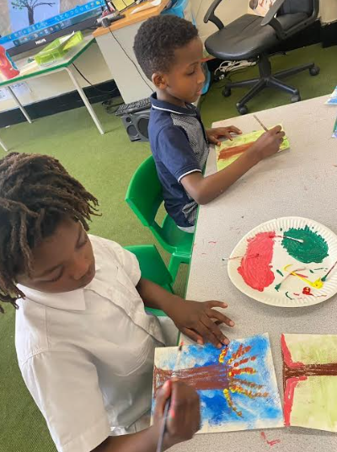
Sessions are delivered by the class teachers and our specialist teacher. Each year group will have at least 3 artist studies throughout the year. Within these artist studies, children will be given the opportunity to discuss, critically analyse and take inspiration from the work of these artists. Children will practice using the skills and techniques that the artist has used in their work and will then produce a piece of art work in response.
Each session builds upon prior learning, ensuring that there are opportunities for children to revisit previous learning, thus facilitating opportunities for children to know and remember more and they are encouraged to use and apply the skills and techniques taught previously in their upcoming sessions. Each year group will also revisit the key knowledge and skills from their previous year groups to ensure that they retain the information and address any gaps.

EYFS
In the Early Years Foundation Stage, our curriculum is taken from the statutory framework. Within Expressive Arts and Design, children are taught to create with materials and be imaginative and expressive. Children will be given the opportunity to safely use and explore a variety of materials, tools and techniques. They will also experiment with colour, design, texture, form and function. Our topics help to prepare them for learning in Year 1 where they will learn to cut, roll and coil materials, name the primary and secondary colours, create moods in their art work and use pencils to create lines of different thickness in drawings.
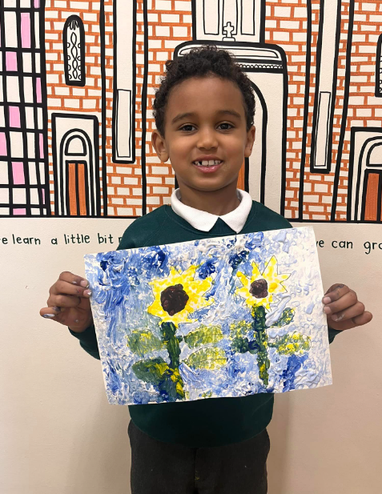
Reading
We have plenty of books to support our Art & Design curriculum. At the beginning of each lesson, we share books with our children either about the artist they are going to be studying or about the techniques they will be using. These books are displayed in our classrooms, corridors and our whole school library. Children can learn about inspirational artists and designers who have changed our world for the better by reading the books in our library.

What does assessment look like in Art and Design?
In each Art and Design lesson, we are continually assessing our children to find out what they know and what they need to know next. We assess children in a variety of ways. For example, by observing children using the various skills and techniques taught or by questioning and discussing what they have been learning throughout the lesson. We also provide opportunities for children to assess their own learning and that of their peers by allowing them to share their art work and reflect on their strengths and areas for development.
We do not assess children on their final piece of art work as we recognise that Art and Design is very subjective and opinions differ. However, we do assess children on their ability to explain, develop and apply the skills and techniques taught.
Teachers and our specialist teacher assess the children twice a year against the age-related expectations, identifying whether they are working towards the expected standard or working at the expected standard. This data is analysed by the subject leader and teachers and used to inform future planning, ensuring that the needs of the children are met.

How do we provide extra support and challenge to those who need it?
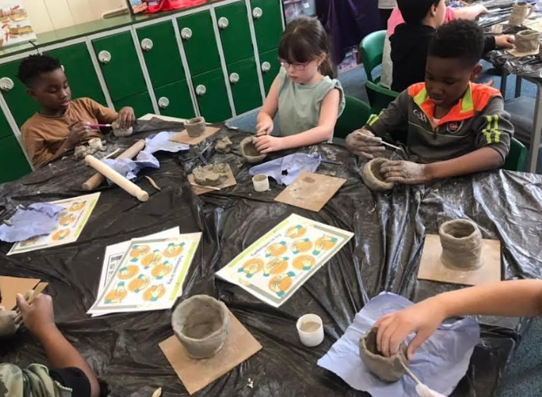
Within every lesson we provide children with equal opportunities to learn, ensuring an inclusive learning environment. However, through the continuous assessment within lessons, teachers are able to identify children who may need extra support or challenge. We have various different methods of supporting children and we select the best method for each individual child as we recognise that no two children are the same and what works best for them will be specific to their needs. We may support a child through; targeted support from a teacher or teaching assistant, extra demonstrations and modelling, breaking down the learning into smaller steps or using appropriate and/or modified resources to support their fine motor skills.
Within the lesson, we may also identify a child who needs further challenge to deepen their learning. We may support the child to refine their skills and techniques or we may ask them to discuss their work and the techniques they have used and why to gain a better understanding.

Safeguarding and well-being
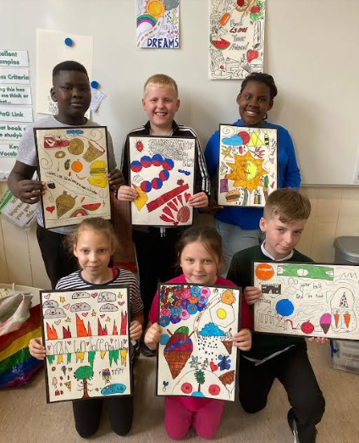
A child’s welfare, well-being and safety is of the utmost importance to us. A child can’t learn or make any progress in school if they don’t feel safe and secure. We all know they need to be happy and we are here to ensure all of our children are nurtured to reach their full potential. Sometimes, learning in a lesson can trigger something to upset a child. We have a special programme in school to help any children who may be struggling with their emotions and well-being. If you have any concerns about your child or in fact another child, please do not hesitate to contact one of our Designated Safeguarding Leads who will be happy to talk through any concerns you may have.

Personal Development
We know how Art and Design has such a positive impact on children’s personal development and we will do our best to enrich the curriculum by providing educational visits to support their learning. By studying carefully selected artists from the past and present we aim to help children make links between what they are learning in class and their own lives. Some of our pupils worked with the artist Myro Doodles and had the opportunity to ask her questions about her work and home life. We aim to provide more opportunities like this for children to meet and work with artists in the local area.

How can I support my child’s learning in Art and Design?
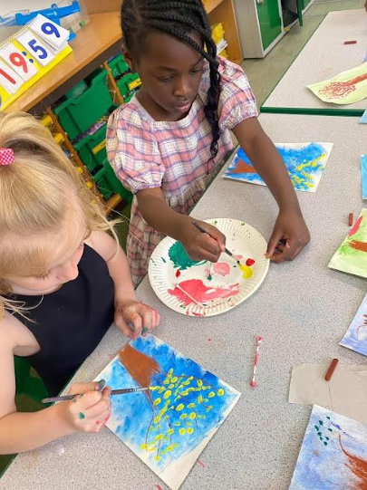
There is lots you can do to support your child and it doesn’t have to be expensive or time consuming. There are very few children who don’t like being creative! Children will spend hours doing, making and experimenting if you give them the resources, space and time to do so. Yes, the younger children need supervision, especially if they are going to be cutting and/or gluing. However, this is time well spent and you will get endless conversation and new vocabulary from them if you allocate a wet afternoon over a weekend. Older children love to colour, paint or sketch. They love to use their imagination and creating art is superb for our mental well-being. It’s something you could do as a family! There will be some suggested activities for you to do on the termly knowledge organisers available via email.
Out and about
We encourage you to get out and about with your children. Manchester has many places for you to visit so why not give these a try?
Manchester Art Gallery
Whitworth Art Gallery
The Lowry
Salford Museum & Art Gallery

