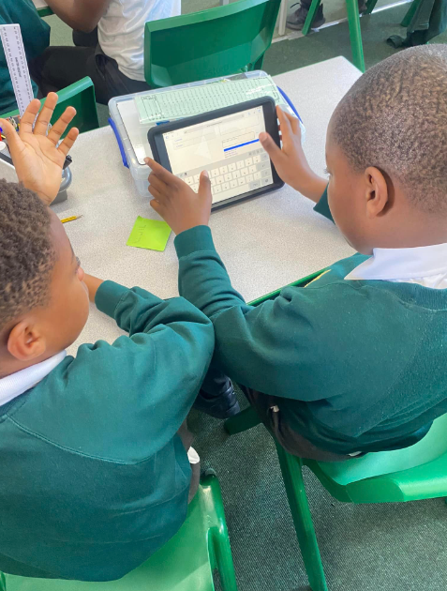
What does Computing looks like at our school?
At our school we believe that computing helps to prepare the children for life in 21st century Britain, encouraging children to develop a greater understanding of technology and the technological world around them. Computing ensures that pupils become digitally literate – able to use, and express themselves and develop their ideas through, information and communication technology – at a level suitable for the future workplace and as active participants in a digital world.

The curriculum is designed to meet the aims of the National Curriculum. We aim to build high levels of competence in the subject specific skills of:
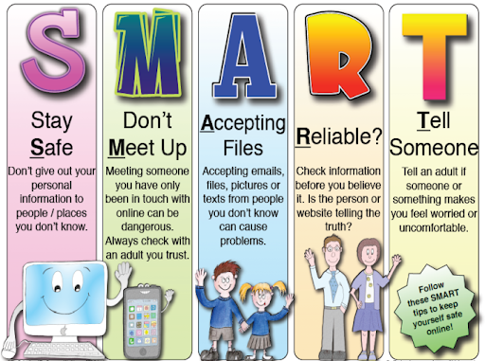
- Algorithms and Programming – For example: Understanding how to write code and using these skills to program Bee-Bots, create animations on Scratch and platform games on Kodu.
- Information Technology – For example: Learning how to use the different programs on Microsoft Office, how to record and edit videos, how to create QR codes and collect and present data in different ways.
- Digital Literacy – This strand has a heavy focus on internet-safety. Internet-safety is taught on every computing day and celebrated every year during Safer Internet-Week.

Our curriculum is regularly refined in line with the latest guidance, subject research reports from Ofsted and current affairs.

What does a Computing day look like in our school?

KS1 & 2
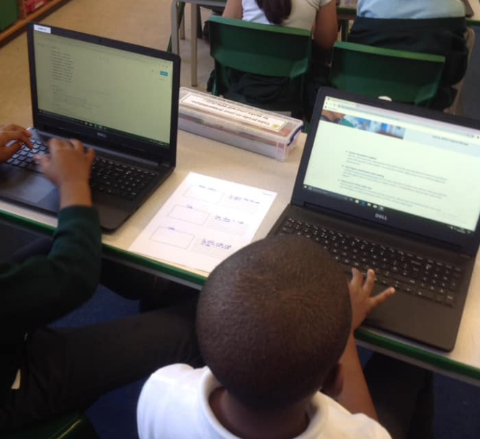
Computing is taught on computing days, with each class being assigned one computing day every half term. Computing is taught through a scheme called ‘JE Computing’. Through the JE Computing scheme, each class completes 6 units called ‘Projects’. These projects are titled;

>I’m a computational thinker
>I’m a computer programmer
> I’m a creative user of technology
> I’m a data producer
> I’m an online communicator and collaborator
> I’m a responsible digital citizen.

The skills learnt are then used and applied in other subjects- such as maths, science, humanities. This helps ensure children are having more opportunities to practice and therefore remember the skills they have learnt.
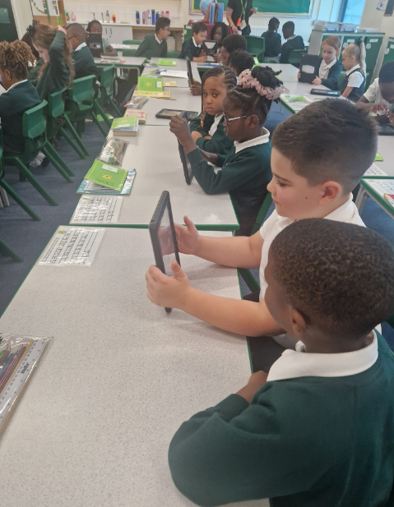
A class floor book is kept for each class to record coverage within the subject and key reference to where the children meet the age-related expectations as well as flash back 4 for computing. It also includes a description of the activities completed that day, pictures of the children completing their activities, evidence of the work completed, pupil voice and links to previous learning. Each year group has their own class login and an individual file to save their work on the system.

Internet-safety is incorporated into each computing day and Safer Internet-week is a key part of the school calendar. It is vital that children have a good understanding of internet-safety and understand how to keep themselves and others safe online. This prepares our children for life in the 21st century and helps them grow to be responsible and tolerant citizens.

EYFS
If your child is in Nursery or Reception, they will join our Early Years Foundation Stage (EYFS). Our curriculum is taken from the statutory framework. At our school we ensure that all areas of EYFS learning are important and interconnected using planned, purposeful play and a mix of adult-led and child-initiated activities. In EYFS, your child will start to gain the computing knowledge that they’ll build on throughout their primary school years. Our computing topics are built upon the foundation knowledge and skills and are closely linked to the learning in Year 1.

Reading
What has Computing got to do with reading? Well, if your child is struggling to read, they aren’t going to be able to access the curriculum. Lots of the instructions children have to follow in Computing are written down and the children need to be able to read them. We have a saying in our school, ‘we learn to read so we can read to learn.’ So, please support your child with all of their learning by hearing them read each night.
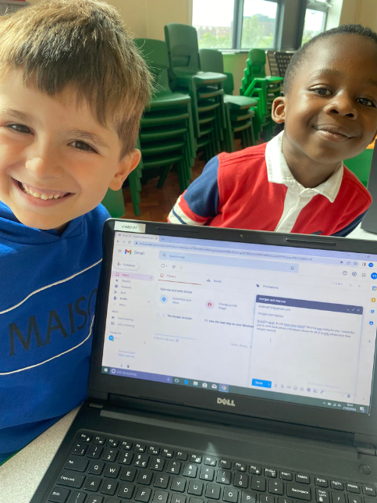
What does assessment look like in Computing?
The work the children produce is evidenced in the class floor book as well as on Facebook. The class teacher has an assessment sheet for each computing day and each child is assessed on each computing day, which helps the teacher formulate the end of year assessments for the class. The children also complete a self-assessment at the end of each computing day to evaluate their own learning- including what they did well and what they think they could do better next time.

Providing extra support and challenge to those who need it
Within every lesson we provide children with the same chances and opportunities to learn ensuring an inclusive learning environment. However, through the continuous assessment within lessons, teachers are able to identify children who may need extra support or challenge. We have various different methods of supporting children and we select the best method for each individual child as we recognise that no two children are the same and what works best for them will be specific to their needs. We also ensure each computing project has additional challenges for our children to complete which helps extend their learning and
inspire them to become further independent learners.

How do we adapt our computing Curriculum?
We know how important it is to give pupils the time they need to repeat or practise some of their learning so that they can remember it in the long term when they progress through school and onto High School. Our computing curriculum is progressive and knowledge and skills are built on incrementally. The scheme highlights links to prior learning and we have identified links to future topics and jobs in this field in the future. Teachers use information from assessments to inform planning, ensuring that any foundation skills, knowledge and vocabulary missed are included in planning and the delivery of teaching so that all children are given the opportunity to be successful in their learning. Teachers know that children learn at different rates and require different types of support for all sorts of reasons and our plans are adapted accordingly to meet the needs of our pupils.

How can I support my child’s learning in Computing?
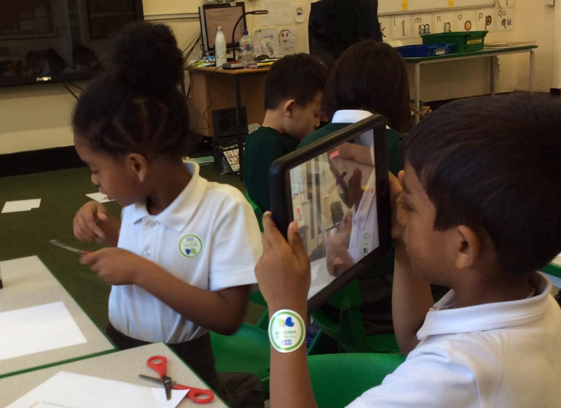
There is lots you can do to help your child with computing. For starters, all children have been given login details to access our online learning programs: Mathletics, Numbots, Timestable Rockstars & BugClub. All of these will support learning in Maths and Reading. Furthermore, the computing software programs we use in school can be accessed at home, for example, Scratch and Kodu.

Safeguarding and well-being

A child’s welfare, well-being and safety is of the utmost importance to us and this remains the same when they are learning online too. A child can’t learn or make any progress in school if they don’t feel safe or secure. We all know they need to be happy and we are here to ensure all of our children are nurtured to reach their full potential.
There are elements of the JE Computing scheme of work that have a strong safeguarding focus and our philosophy is to grow resilience as well as a positive self-esteem and confidence in children, so they can recognise when they feel uncomfortable in a situation and know who to trust and how to speak up for help. Our Designated Safeguarding Leads are available to discuss any concerns you may have about your child.

The biggest responsibility parents have though is keeping your child safe whilst they are online. Please make sure you monitor what your child is accessing and that it is age appropriate. We have a termly newsletter for parents specifically about keeping your child safe. This is available on the school website. If you would like any help with how to set up parental locks etc, please do not hesitate to contact your child’s class teacher.

