What does Design and Technology look like at our school?
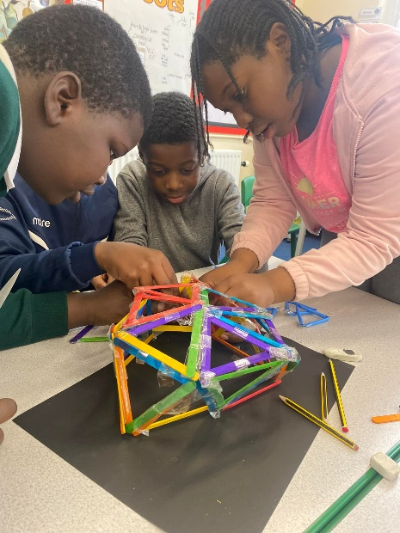
Our Design & Technology curriculum has been designed to meet the statutory requirements of the National Curriculum; the programmes of study being the basis for learning and adapted to meet the needs of our pupils. Our curriculum is regularly refined in line with the latest guidance, subject research reports from Ofsted and current affairs.

At our school, we recognise the importance of Design and Technology lessons and the impact they have on a child’s ability to interrelate with the world and environment around them. Through Design and Technology, children are provided with the opportunity to develop a creative mind-set whilst also to develop skills, knowledge and understanding of designing and making functional products. We feel it is vital to nurture creativity and innovation through design, and by exploring the designed and made world in which we all live and work.

Within the Design and Technology curriculum, we teach children to investigate and evaluate existing, functional products within our world. This enables the children to construct and influence their own designs with a perception of what makes a product successful when making their own. We endeavour to encourage experimentation within this subject whilst supporting the children on their journey of applying the key skills required to achieve their end product.

Our Design and Technology curriculum has been planned by our subject leader, curriculum leader and QA advisor, alongside our specialist D&T teacher, Mrs Phillips. The lessons are linked to the Humanities and Science topics for each half-term to create a cross-curricular approach.

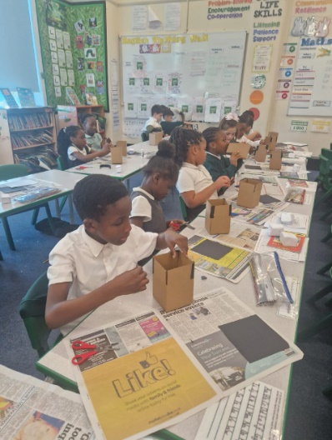
What does a Design and Technology lesson look like in our school?
Sessions are delivered by the class teachers and our specialist teacher. Each year group will study the five aspects of Design and Technology (structures, mechanisms, food and nutrition, textiles and electronics), children will be given the opportunity to investigate and evaluate existing functional products, complete focused tasks to develop specific skills and techniques and finally, design, make and evaluate their final product. Within our lessons, children will learn about the designed and made world, how products work within this, and learning to design and make functional products for particular purposes and users.

Each session builds upon prior learning ensuring that there are opportunities for children to revisit previous learning, thus facilitating children to know and remember more. Children will be encouraged to use and apply the skills and techniques taught previously in their upcoming sessions. Each year group will also revisit the key knowledge and skills from their previous year groups to ensure that they retain the information and address any gaps.
The skills learned within Design and Technology supports children’s education across the wider curriculum as the knowledge that children acquire of the properties of materials will support Science lessons. Similarly, the practice of measuring accurately can scaffold learning in Mathematics. Through Design and Technology, children’s skills are developed through collaborative working and problem-solving, and knowledge in design, materials, structures, mechanisms and electrical control. We continuously link our curriculum to the wider world around us by actively encouraging the children to reflect on important issues such as sustainability and enterprise when being creative and innovative within their projects.

EYFS
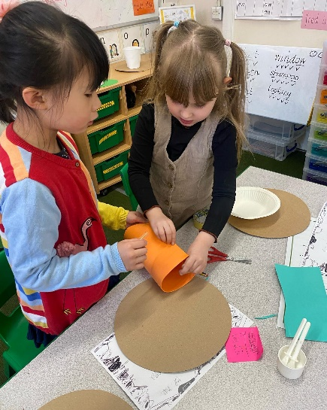
In the Early Years Foundation Stage, our curriculum is taken from the statutory framework. Within Expressive Arts and Design, children are taught to create with materials and be imaginative and expressive. Children will be given the opportunity to safely use and explore a variety of materials, tools and techniques. This will help prepare them for learning in Year 1 where they will be taught to cut materials safely using the tools provided, join materials and components in different ways and make a product which moves. Within Early Years, children are also taught to share their creations and explain the process they have used, again preparing them for KS1 where they will learn to think of an idea and plan what to do next, explain how they want to make their product, choose the most appropriate tools and resources and explain how something works.

Reading
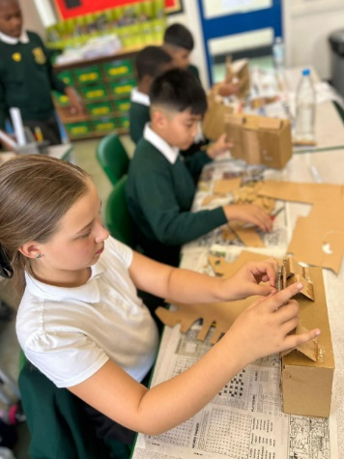

We have plenty of books to support our Design & Technology curriculum. At the beginning of each lesson, we share books with our children about the key people and events that they will be learning about. These books are displayed in our classrooms, corridors and our school library. Children can learn about inspirational pioneers, such as fashion designers, engineers, chefs and architects, who have changed our world for the better by reading the books in our school and class libraries.

What does assessment look like in Design and Technology?
In each Design and Technology lesson, we are continually assessing our children to find out what they know and address what they need to know next. We assess children in a variety of ways for example, by observing children using the various skills and techniques taught or by questioning and discussing what they have been learning throughout the lesson. We also provide opportunities for children to assess their own learning and that of their peers by allowing them to evaluate their products and reflect on their strengths and areas for development. We assess children on their ability to use, remember and develop the skills and techniques taught and whether the products created are functional, purposeful and meet the design criteria.

How do we provide extra support and challenge to those who need it?
Within every lesson we provide children with equal opportunities to learn ensuring an inclusive learning environment. However, through the continuous assessment within lessons, teachers are able to identify children who may need extra support or challenge. We have various different methods of supporting children and we select the best method for each individual child as we recognise that no two children are the same and what works best for them will be specific to their needs. We may support a child through; targeted support from a teacher or teaching assistant, extra demonstrations and modelling, breaking down the learning into smaller steps or using appropriate resources to support their fine motor skills. Within the lesson, we may also identify a child who needs further challenge to deepen their learning. We may support the child to refine their skills and techniques or we may ask them to discuss their work and the techniques they have used and why to gain a better understanding.

Safeguarding and well-being
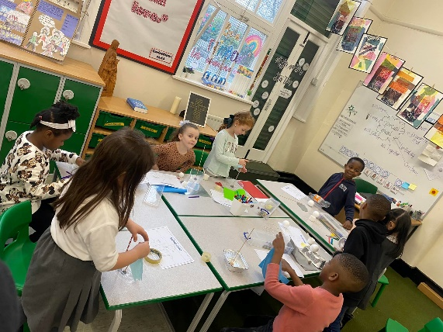
A child’s welfare, well-being and safety is of the utmost importance to us. A child can’t learn or make any progress in school if they don’t feel safe and secure. We all know they need to be happy and we are here to ensure all of our children are nurtured to reach their full potential. Sometimes, learning in a lesson can trigger something to upset a child. We have a special programme in school to help any children who may be struggling with their emotions and well-being. If you have any concerns about your child or in fact another child, please do not hesitate to contact one of our Designated Safeguarding Leads who will be happy to talk through any concerns you may have.

Personal Development
We know how Design & Technology has such a positive impact on children’s personal development and we will do our best to enrich the curriculum by providing educational visits to support their learning. By learning about designers, engineers, architects and chefs from the past and present we aim to help children make links between what they are learning in class and their own lives.

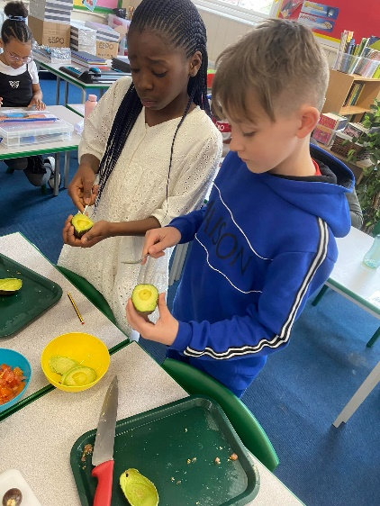
How can I support my child’s learning in Design & Technology? There is lots you can do to support your child and it doesn’t have to be expensive or time consuming. There are very few children who don’t like being imaginative! Children will spend hours doing, making and experimenting if you give them the resources, space and time to do so. Yes, the younger children need supervision, especially if they are going to be cutting and/or gluing. However, this is time well spent and you will get endless conversation and new vocabulary from them if you set aside some time either over a weekend or during a school holiday. Also...get cooking! Children LOVE to cook and bake so involve them from the very start of the process. They will be far more likely to eat their meals if they are involved in making them! There will be some suggested design & technology activities for you to do on the termly knowledge organisers available via email so take a look for some great ideas.

Out and about
We encourage you to get out and about with your children. Manchester has many places for you to visit so why not give these a try?
Manchester Science & Industry Museum
Museum of Transport
Manchester Art Gallery
Whitworth Art Gallery
The Lowry
Salford Museum & Art Gallery

